**DR.ZAKIR HUSAIN COLLEGE, ILAYANGUDI**

**P.G DEPARTMENT OF MATHEMATICS**

# PROJECT TITLE:

CHARTING THE COURSE OF INNOVATION: A STARTUP ANALYSIS

**Submited by,**

|  |  |  |  |
| --- | --- | --- | --- |
| **Name of the student** | **University Reg No.** | **Naanmudhalvan ID** | **Smartinternz ID** |
| **I.ALSHIFA** | **0620121003** | **asalu6620121003** | **NM2023TMID09524** |
| **S.ANUSIYA DEVI** | **0620121005** | **asalu6620121005** | **NM2023TMID09524** |
| **S.ARUNA DEVI** | **0620121006** | **asalu6620121006** | **NM2023TMID09524** |
| **P.HARINI** | **0620121015** | **asalu6620121015** | **NM2023TMID09524** |

***Faculty Incharge*:**

**Dr.A. ARIF RAHMAN,**

**ASSISTANT PROFESSOR,**

**DEPARTMENT OF MATHEMATICS,**

**Dr.ZAKIR HUSAIN COLLEGE, ILAYANGUDI.**

**1. INTRODUCTION**

***1.1 OVERVIEW***

The term startup refers to a company in the first stages of operations. Starting a new company can be an exciting and rewarding experience but it also requires careful planning and analysis to ensure that the business is viable and successful. On a high level, a startup works like any other company.

***1.2 PURPOSE***

A startup analysis is essential to the success of any startup business. It allows entrepreneurs to identify the key areas that need improvement and make necessary changes early on. Doing a startup analysis also allows startups to track their progress and ensure that they are on track to achieve their goals.

**2. PROBLEM DEFINITION & DESIGN THINKING**

***2.1 EMPATHY MAP***

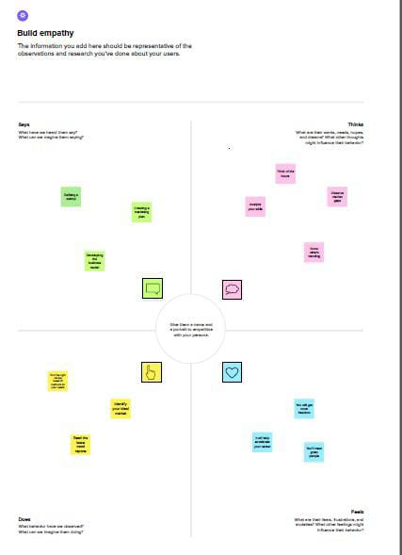

***2.2 IDEATION & BRAINSTORMING MAP***

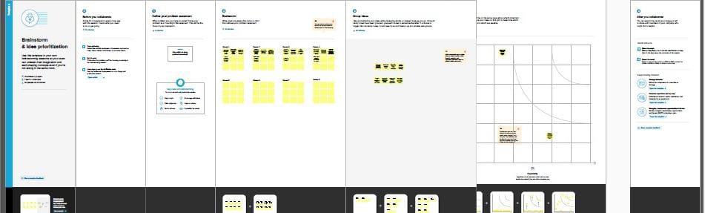

**3. RESULT**

***Dashboard***



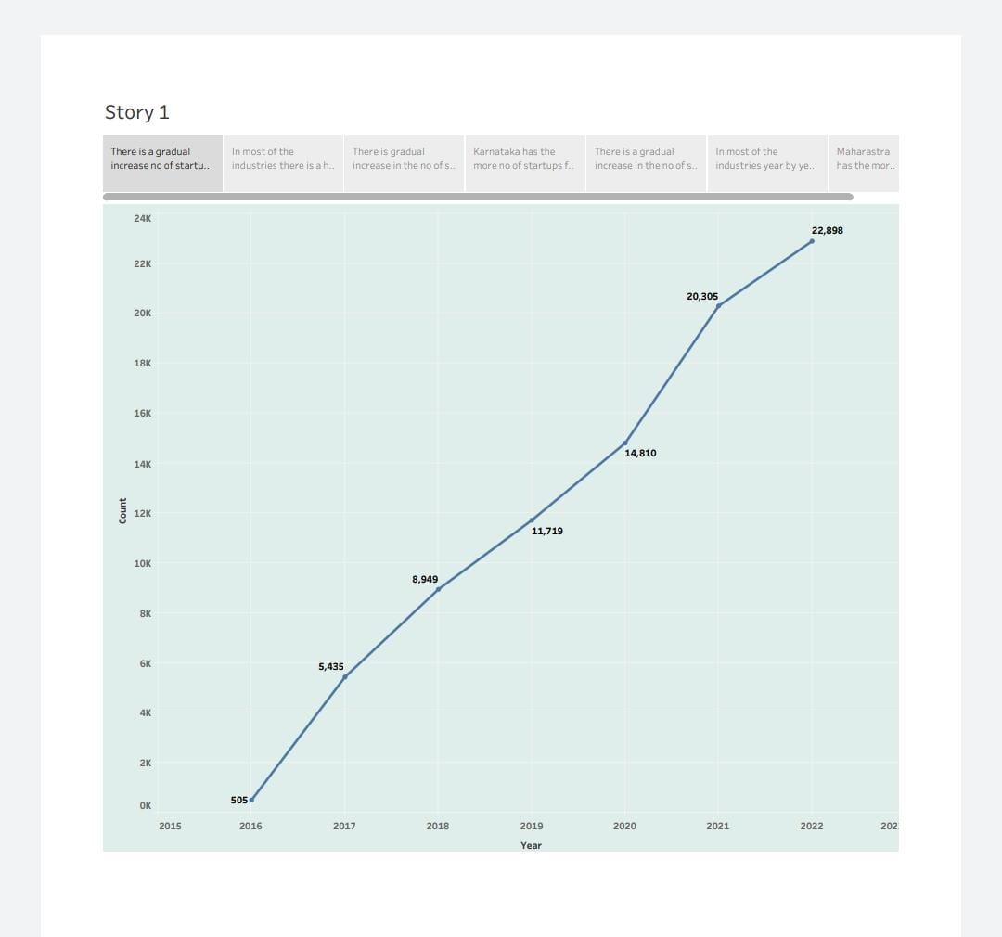

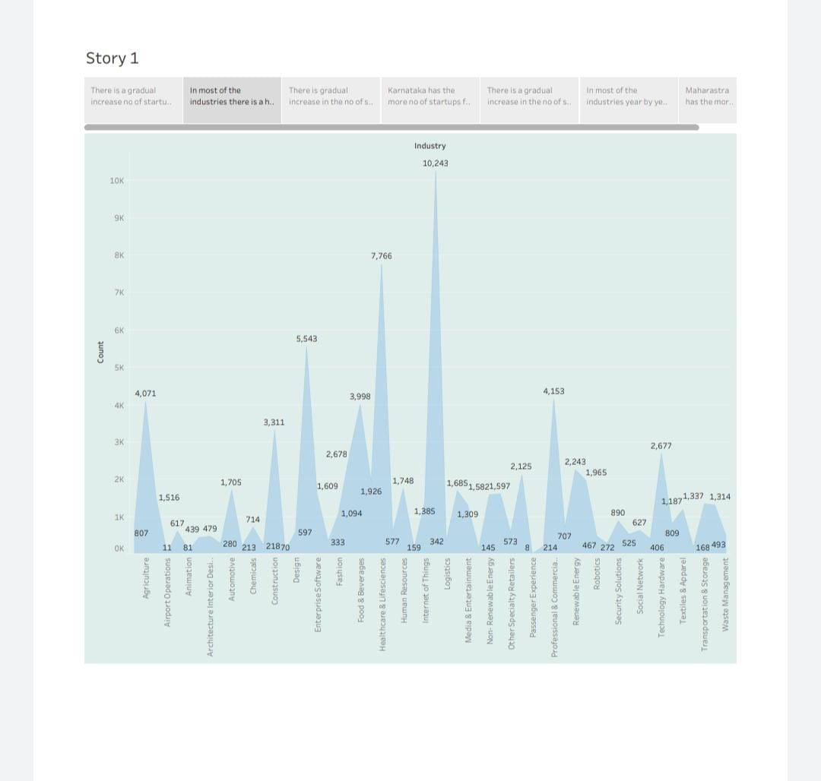

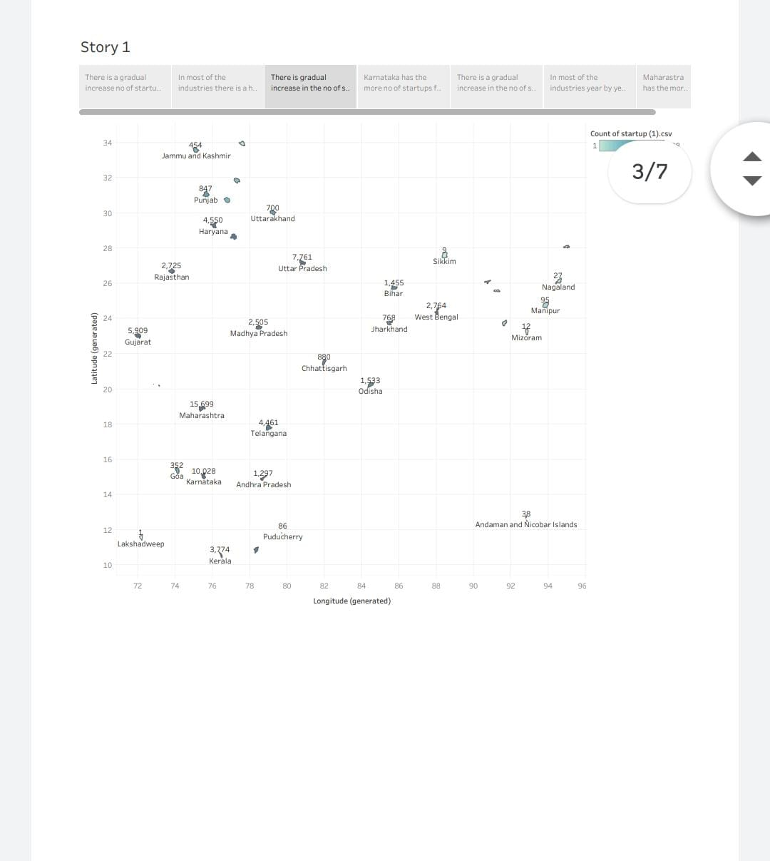

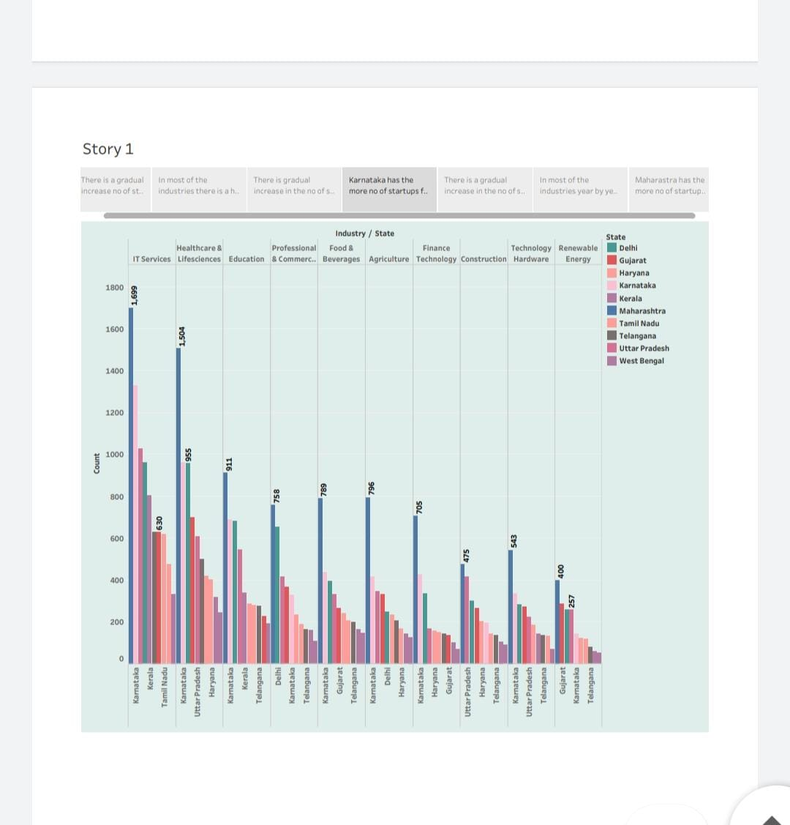

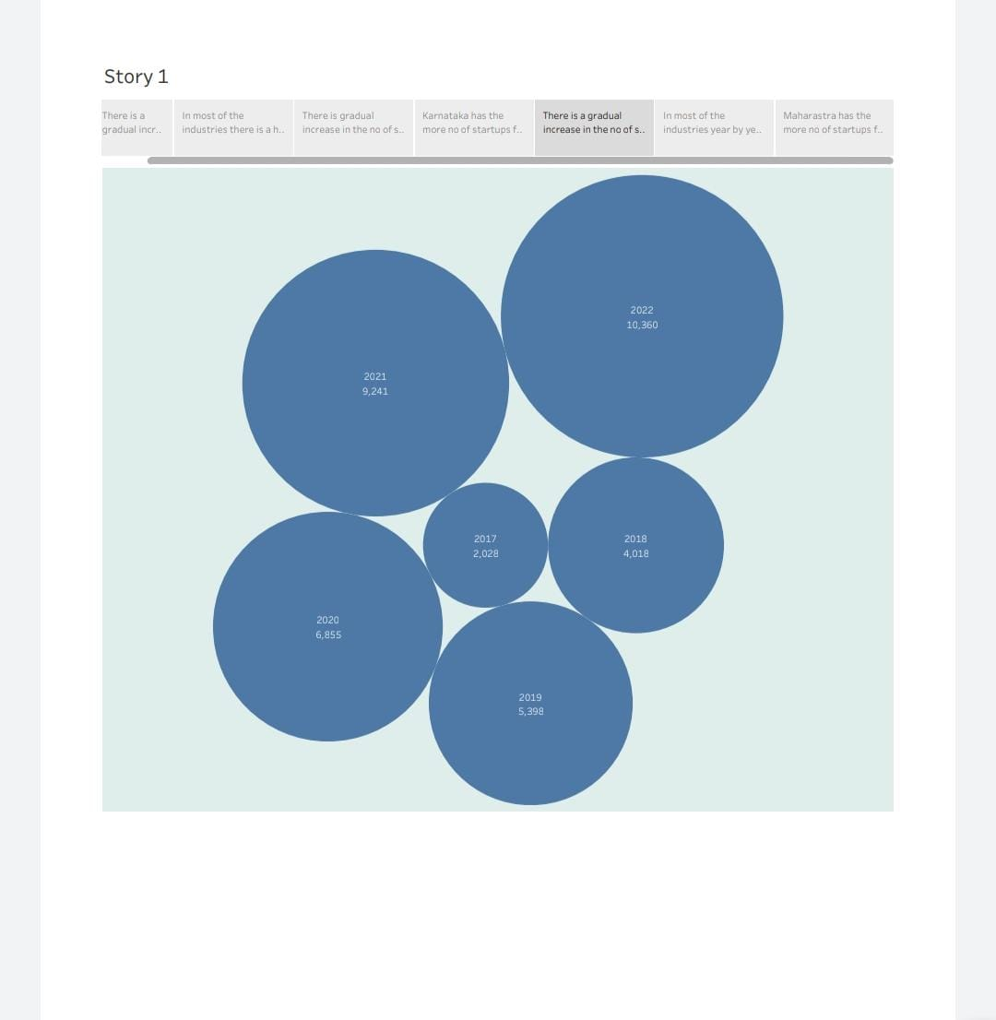

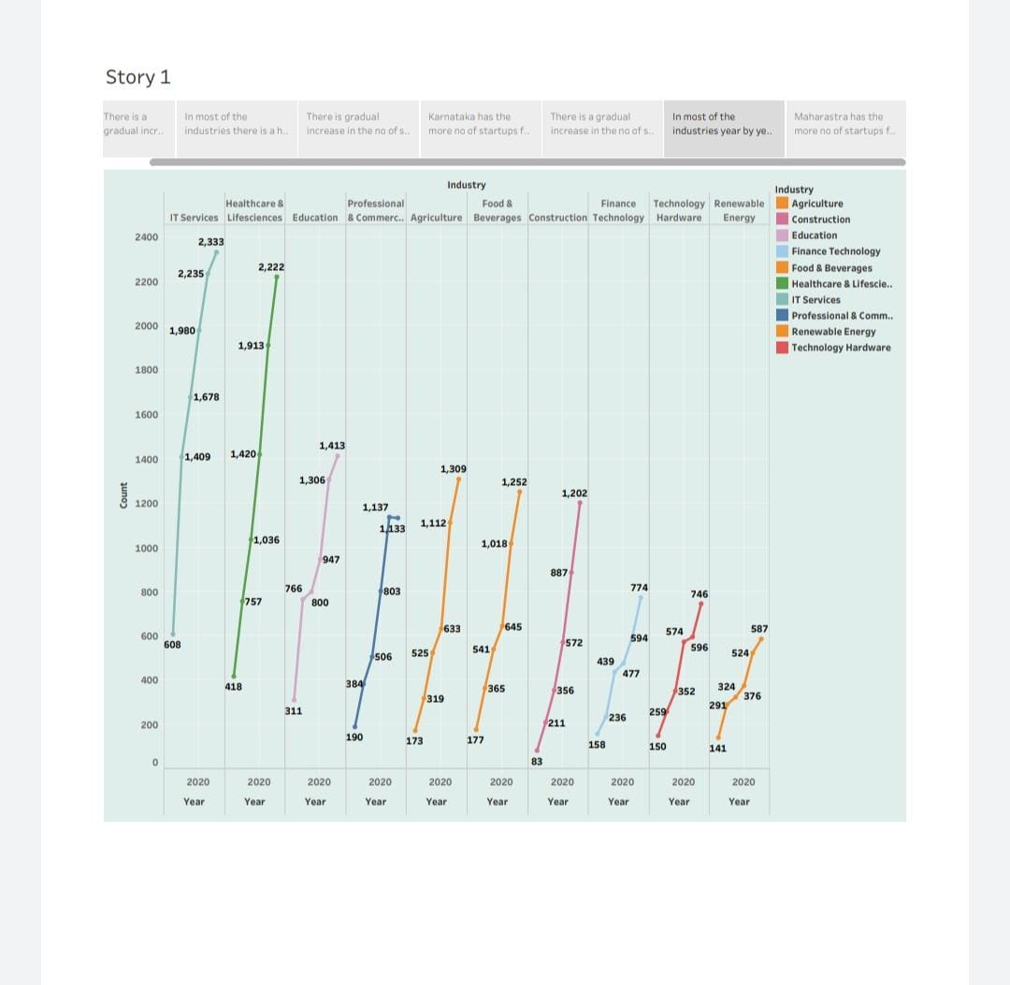

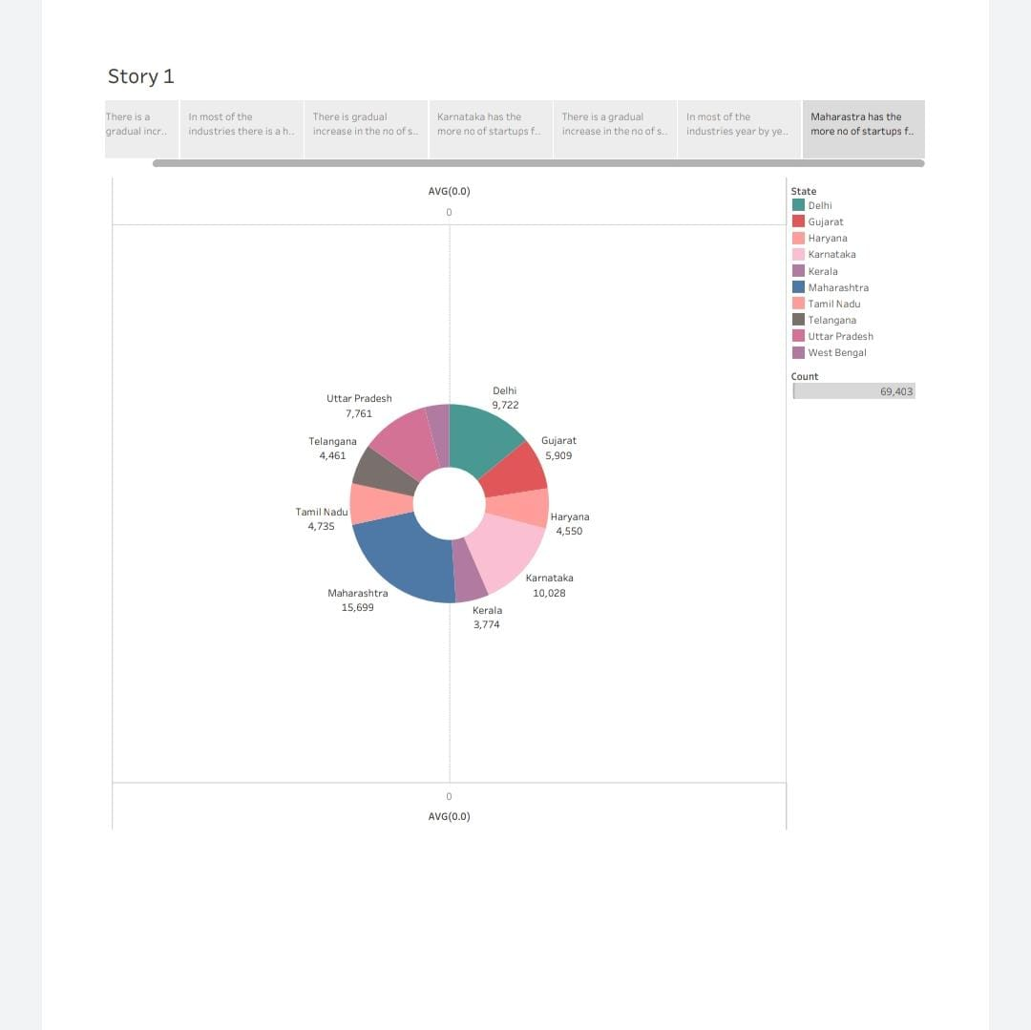

4.ADVANTAGES AND DISADVANTAGES

***ADVANTAGES:***

* The versality of startup employees is reinforced by a team culture that encourages learning and innovation.
* Startups deliver their products and services with a personal touch and create a unique a personal experience for their customer.
* Startups have lower administrative overheads and offer their services in an efficient.
* Cost-effective and competitive manner.
* Startups are smaller and less structured, so they can adapt to disruptive technologies and changes in market conditions.

***DISADVANTAGES:***

* Most startups fail within their first year of operations, so the risk of failure is high.
* Working under such high risk can blur a startup’s strategic vision.
* It takes blood, sweat and tears to build a company and long working hours are the norm for startups.
* Many customers prefer a business that they have worked with over a new startup.
* Some startups are born out of desperation since the founder could not find or hold on to a job.

5.APPLICATIONS

* Data analysis helps give businesses the facts needed to make decisions.
* It gives us an edge because a lot of competitors are not using data to drive their decisions.
* It can spot trends, reveal hidden opportunities, or help explain problems.
* Understanding the needs of the business and finding ways to improve efficiency and effectiveness.

6. CONCLUSION

While the world-changing potential in startups is sometimes overhyped, successful startups do have the potential to create a significant positive impact on the world. And even when startups fail, they still have an impact, especially through the learnings for the founders, employees, investors and other stakeholders.

7. FUTURE SCOPE

* Startups are small companies but they play a big role in the economic process.
* They create more jobs which insinuates more employment.
* With a growing economy, increasing technological traditional business models.
* The scope for Indian startups is immense in various sunrise and sustainable development sectors such us green energy, health tech, deep tech and clean mobility.

8.APPENDIX

***A SOURCE CODE***

<!DOCTYPE html>

<html lang="en">

  <head>

    <meta charset="utf-8" />

    <title>StartUp</title>

    <!-- mobile responsive meta -->

    <meta name="viewport" content="width=device-width, initial-scale=1" />

    <meta

      name="viewport"

      content="width=device-width, initial-scale=1, maximum-scale=1"

    />

    <!-- theme meta -->

    <meta name="theme-name" content="dtox" />

    <!-- ** Plugins Needed for the Project ** -->

    <!-- Bootstrap -->

    <link rel="stylesheet" href="plugins/bootstrap/bootstrap.min.css" />

    <!-- themefy-icon -->

    <link rel="stylesheet" href="plugins/themify-icons/themify-icons.css" />

    <!-- slick slider -->

    <link rel="stylesheet" href="plugins/slick/slick.css" />

    <!-- venobox popup -->

    <link rel="stylesheet" href="plugins/Venobox/venobox.css" />

    <!-- aos -->

    <link rel="stylesheet" href="plugins/aos/aos.css" />

    <!-- Main Stylesheet -->

    <link href="css/style.css" rel="stylesheet" />

    <!--Favicon-->

    <link rel="shortcut icon" href="images/favicon.ico" type="image/x-icon" />

    <link rel="icon" href="images/favicon.ico" type="image/x-icon" />

  </head>

  <body>

    <!-- navigation -->

    <section class="fixed-top navigation">

      <div class="container">

        <nav class="navbar navbar-expand-lg navbar-light">

          <a class="navbar-brand" href="index.html"

            ><img src="images/logo1.png" alt="logo" width="70" height="70"

          /></a>

          <button

            class="navbar-toggler border-0"

            type="button"

            data-toggle="collapse"

            data-target="#navbar"

            aria-controls="navbar"

            aria-expanded="false"

            aria-label="Toggle navigation"

          >

            <span class="navbar-toggler-icon"></span>

          </button>

          <!-- navbar -->

          <div class="collapse navbar-collapse text-center" id="navbar">

            <ul class="navbar-nav ml-auto">

              <li class="nav-item">

                <a class="nav-link" href="index.html">Home</a>

              </li>

              <li class="nav-item">

                <a class="nav-link" href="about.html">About</a>

              </li>

              <!-- <li class="nav-item">

                <a class="nav-link page-scroll" href="#feature">Feature</a>

              </li>               -->

              <li class="nav-item">

                <a class="nav-link page-scroll" href="story.html">Story</a>

              </li>

              <li class="nav-item">

                <a class="nav-link" href="contact.html">Contact</a>

              </li>

            </ul>

            <!-- <a href="#" class="btn btn-primary ml-lg-3 primary-shadow"

              >Try Free</a

            > -->

          </div>

        </nav>

      </div>

    </section>

    <!-- /navigation -->

    <div class='tableauPlaceholder' id='viz1681977972446' style='position: relative'><noscript><a href='#'><img alt='Story 1 ' src='https:&#47;&#47;public.tableau.com&#47;static&#47;images&#47;ne&#47;new_story_16817261581590&#47;Story1&#47;1_rss.png' style='border: none' /></a></noscript><object class='tableauViz'  style='display:none;'><param name='host_url' value='https%3A%2F%2Fpublic.tableau.com%2F' /> <param name='embed_code_version' value='3' /> <param name='site_root' value='' /><param name='name' value='new_story_16817261581590&#47;Story1' /><param name='tabs' value='no' /><param name='toolbar' value='yes' /><param name='static_image' value='https:&#47;&#47;public.tableau.com&#47;static&#47;images&#47;ne&#47;new_story_16817261581590&#47;Story1&#47;1.png' /> <param name='animate_transition' value='yes' /><param name='display_static_image' value='yes' /><param name='display_spinner' value='yes' /><param name='display_overlay' value='yes' /><param name='display_count' value='yes' /><param name='language' value='en-US' /></object></div>                <script type='text/javascript'>                    var divElement = document.getElementById('viz1681977972446');                    var vizElement = divElement.getElementsByTagName('object')[0];                    vizElement.style.width='1016px';vizElement.style.height='991px';                    var scriptElement = document.createElement('script');                    scriptElement.src = 'https://public.tableau.com/javascripts/api/viz_v1.js';                    vizElement.parentNode.insertBefore(scriptElement, vizElement);                </script>

    <!-- dashboard -->

    <div class="container">

      <div class="row">

        <div class="col-lg-12">

          <!-- <h2 class="section-title">About us</h2> -->

        </div>

        <div class="col-lg-12 mb-100">

                    <div class='tableauPlaceholder' id='viz1671014834447' style='position: relative; margin-top: 10%;'><noscript><a href='#'><img alt='Dashboard 1 ' src='https:&#47;&#47;public.tableau.com&#47;static&#47;images&#47;In&#47;IndianStartup_16709987299350&#47;Dashboard1&#47;1_rss.png' style='border: none' /></a></noscript><object class='tableauViz'  style='display:none;'><param name='host_url' value='https%3A%2F%2Fpublic.tableau.com%2F' /> <param name='embed_code_version' value='3' /> <param name='site_root' value='' /><param name='name' value='IndianStartup_16709987299350&#47;Dashboard1' /><param name='tabs' value='no' /><param name='toolbar' value='yes' /><param name='static_image' value='https:&#47;&#47;public.tableau.com&#47;static&#47;images&#47;In&#47;IndianStartup_16709987299350&#47;Dashboard1&#47;1.png' /> <param name='animate_transition' value='yes' /><param name='display_static_image' value='yes' /><param name='display_spinner' value='yes' /><param name='display_overlay' value='yes' /><param name='display_count' value='yes' /><param name='language' value='en-US' /></object></div>                <script type='text/javascript'>                    var divElement = document.getElementById('viz1671014834447');                    var vizElement = divElement.getElementsByTagName('object')[0];                    if ( divElement.offsetWidth > 800 ) { vizElement.style.width='110%';vizElement.style.height=(divElement.offsetWidth*0.8)+'px';} else if ( divElement.offsetWidth > 500 ) { vizElement.style.width='100%';vizElement.style.height=(divElement.offsetWidth*0.75)+'px';} else { vizElement.style.width='100%';vizElement.style.height='1277px';}                     var scriptElement = document.createElement('script');                    scriptElement.src = 'https://public.tableau.com/javascripts/api/viz_v1.js';                    vizElement.parentNode.insertBefore(scriptElement, vizElement);                </script>

          </div>

        </div>

      </div>

    <!-- footer -->

    <footer

      class="footer-section footer"

      style="background-image: url(images/backgrounds/footer-bg.png)"

    >

      <div class="container">

        <div class="row">

          <div class="col-lg-4 text-center text-lg-left mb-4 mb-lg-0">

            <!-- logo -->

            <a href="index.html">

              <img

                class="img-fluid"

                src="images/logo1.png"

                alt="logo"

                width="70"

                height="70"

              />

            </a>

          </div>

          <!-- footer menu -->

          <nav class="col-lg-8 align-self-center mb-5">

            <ul class="list-inline text-lg-right text-center footer-menu">

              <li class="list-inline-item active">

                <a href="index.html">Home</a>

              </li>

              <li class="list-inline-item">

                <a class="page-scroll" href="#feature">Feature</a>

              </li>

              <li class="list-inline-item"><a href="about.html">About</a></li>

              <li class="list-inline-item">

                <a class="page-scroll" href="#team">Team</a>

              </li>

              <li class="list-inline-item">

                <a class="page-scroll" href="#pricing">Pricing</a>

              </li>

              <li class="list-inline-item">

                <a href="contact.html">Contact</a>

              </li>

            </ul>

          </nav>

          <!-- footer social icon -->

          <nav class="col-12">

            <ul class="list-inline text-lg-right text-center social-icon">

              <li class="list-inline-item">

                <a class="facebook" href="#"><i class="ti-facebook"></i></a>

              </li>

              <li class="list-inline-item">

                <a class="twitter" href="#"><i class="ti-twitter-alt"></i></a>

              </li>

              <li class="list-inline-item">

                <a class="linkedin" href="#"><i class="ti-linkedin"></i></a>

              </li>

              <li class="list-inline-item">

                <a class="black" href="#"><i class="ti-github"></i></a>

              </li>

            </ul>

          </nav>

        </div>

      </div>

    </footer>

    <!-- /footer -->

    <!-- jQuery -->

    <script src="plugins/jQuery/jquery.min.js"></script>

    <!-- Bootstrap JS -->

    <script src="plugins/bootstrap/bootstrap.min.js"></script>

    <!-- slick slider -->

    <script src="plugins/slick/slick.min.js"></script>

    <!-- venobox -->

    <script src="plugins/Venobox/venobox.min.js"></script>

    <!-- aos -->

    <script src="plugins/aos/aos.js"></script>

    <!-- Main Script -->

    <script src="js/script.js"></script>

  </body>

</html>